I ran some code to get the mac address of the 2 ESP32 Microcontrollers
Mainboard ESP mac – ec:e3:34:d1:74:90
2nd board mac - 08:3a:8d:0d:80:2c

Tested wireless communication with ESPNOW between controllers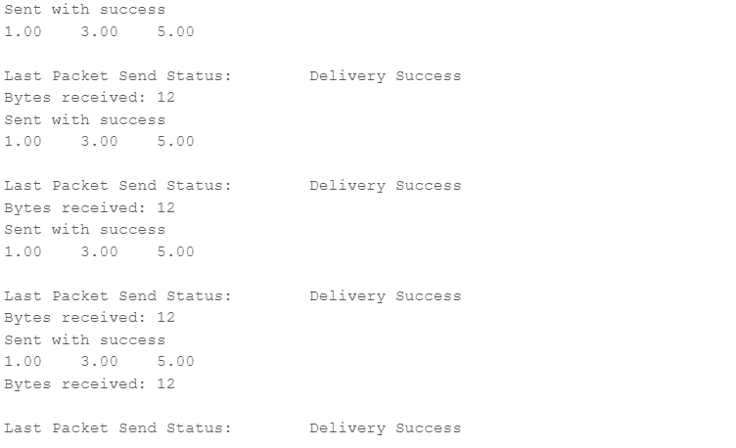
I used the previous testcode to create code that sends 5 numbers from one controller and the other ESP32 calculates the minimum maximum and average of the 5 numbers and sends this back to test the ESPNOW communication works both ways.

Testcode
5 numbers second board
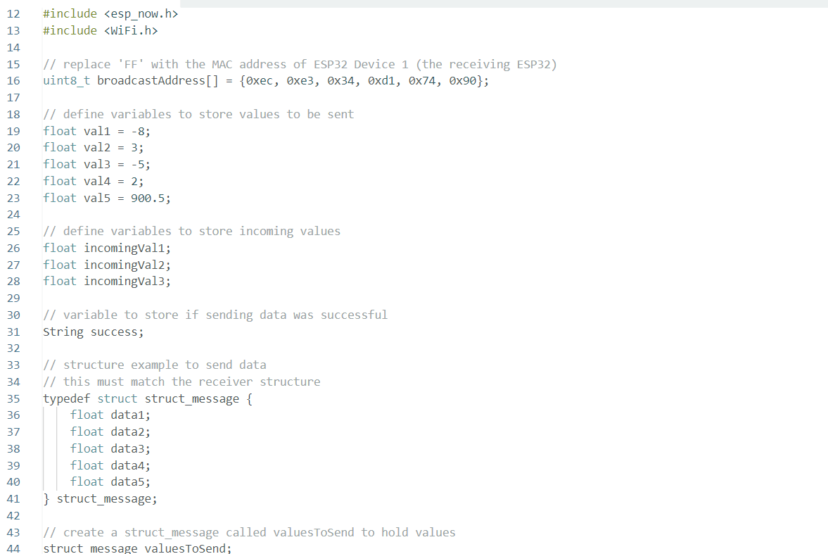
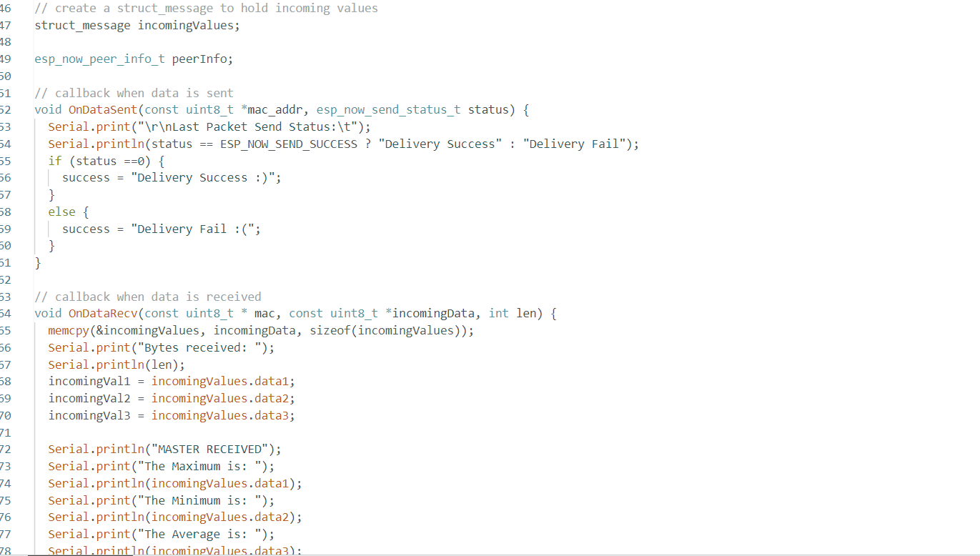
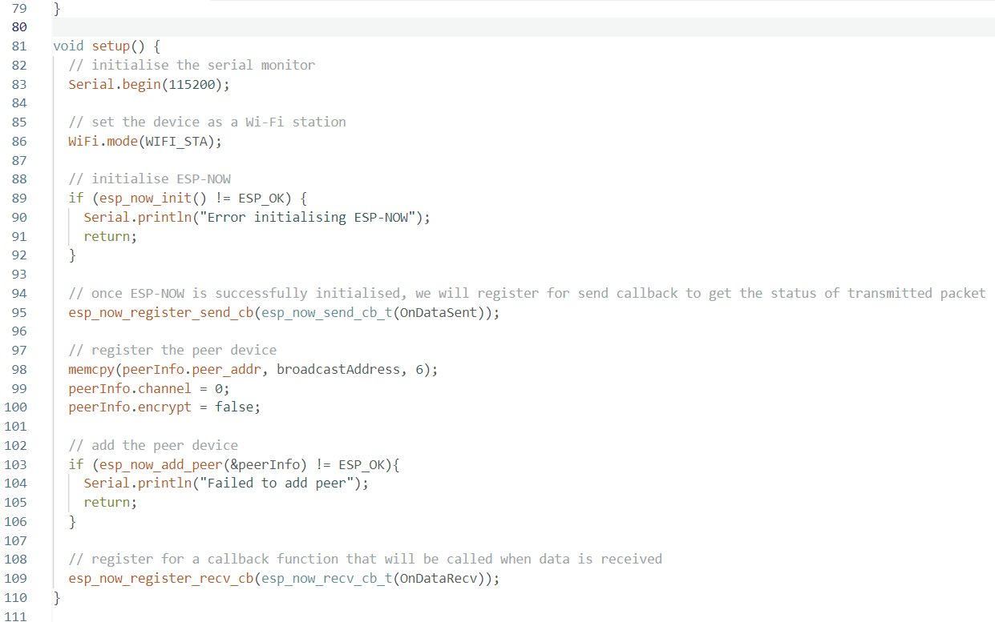
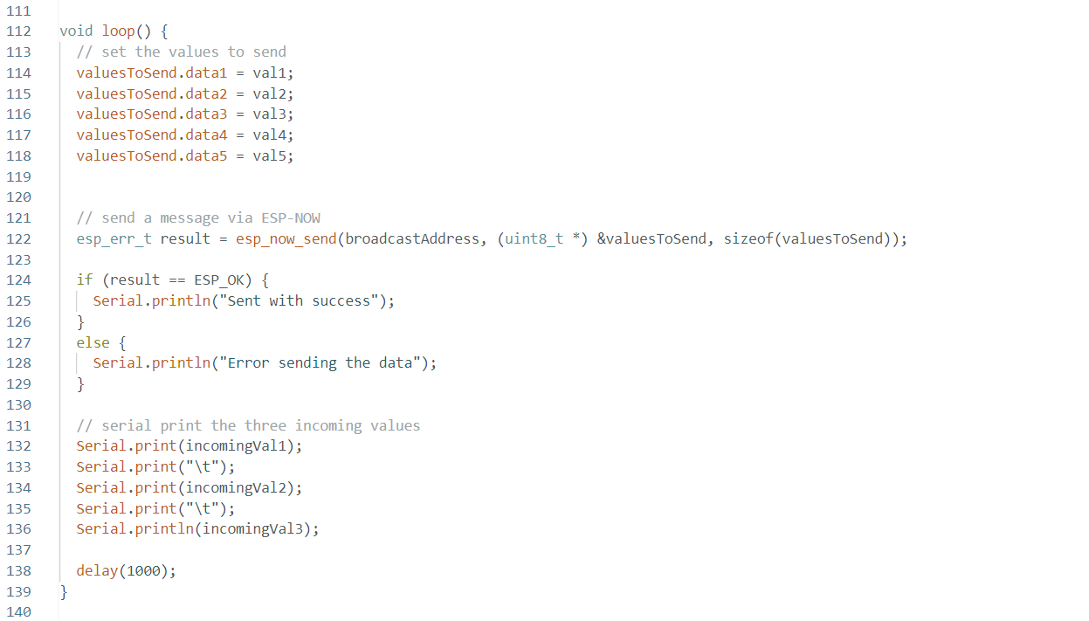
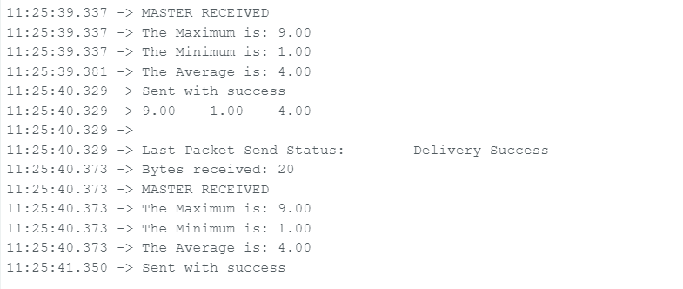
Main board 5 numbers
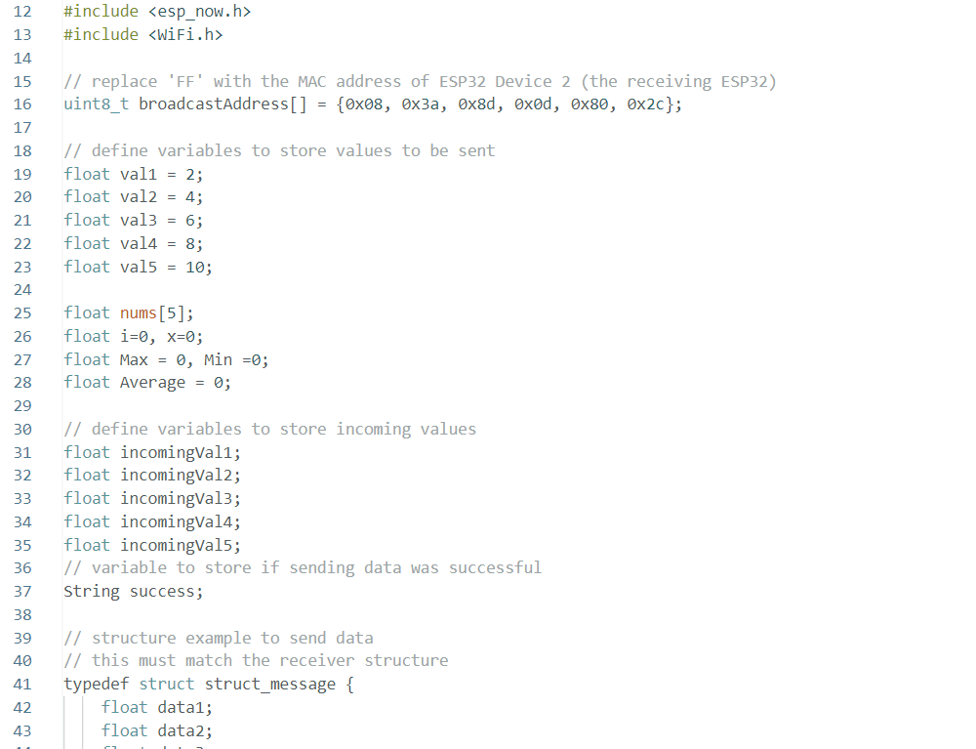
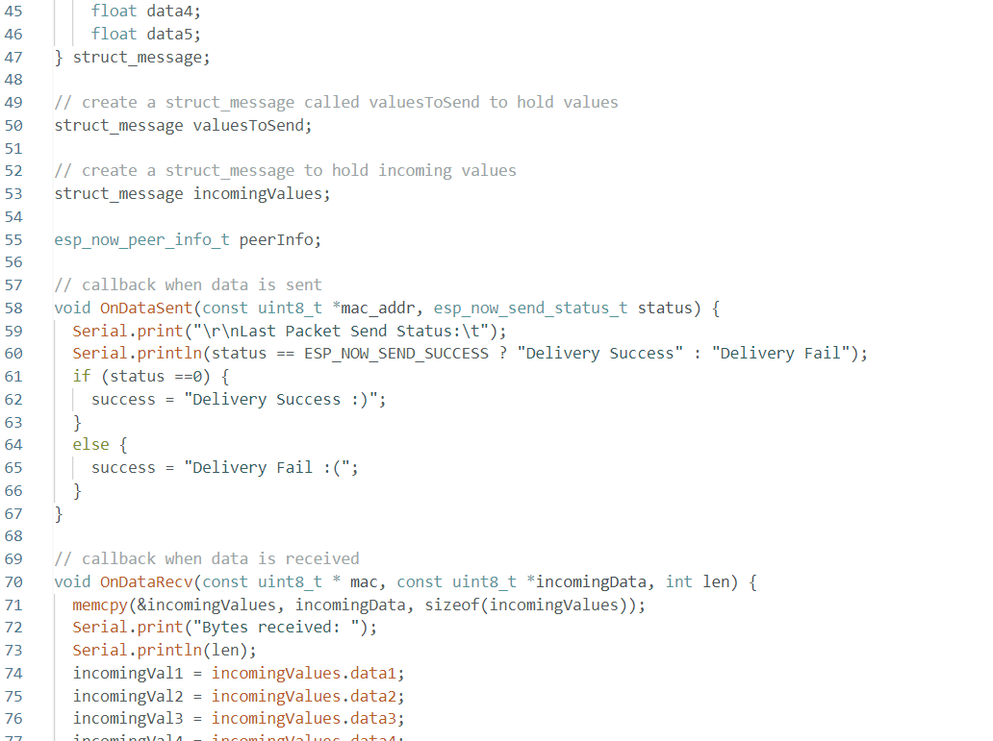
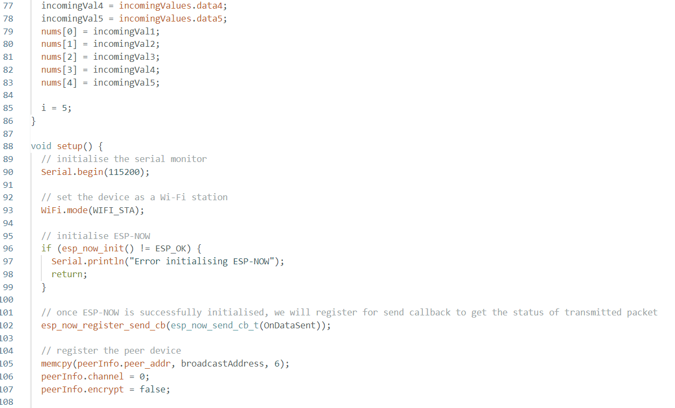
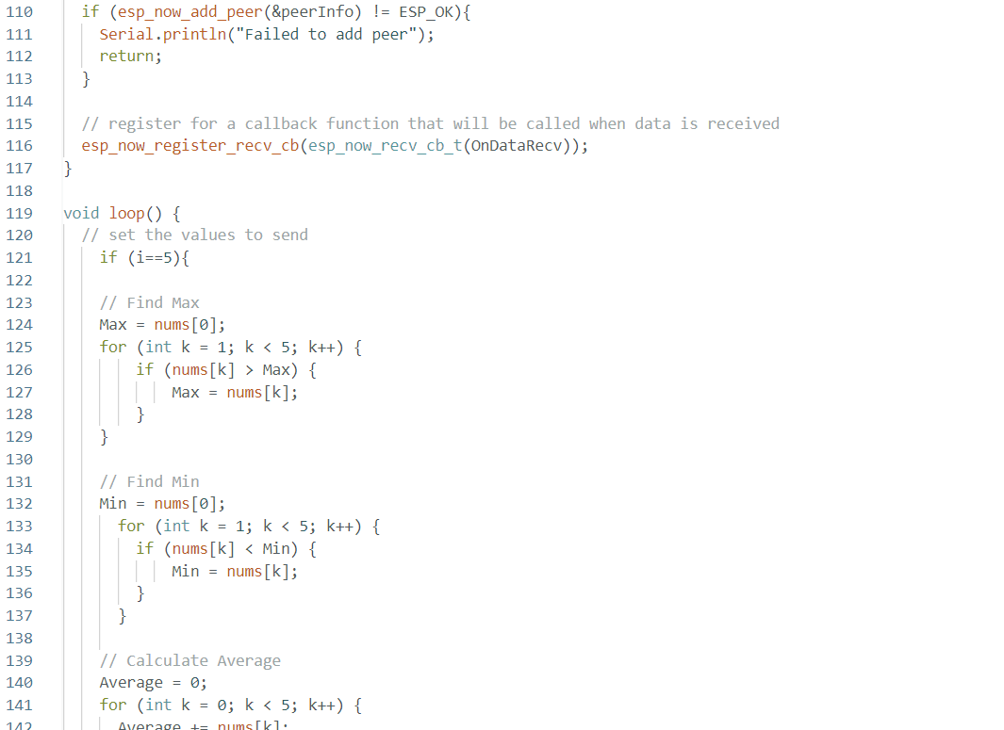
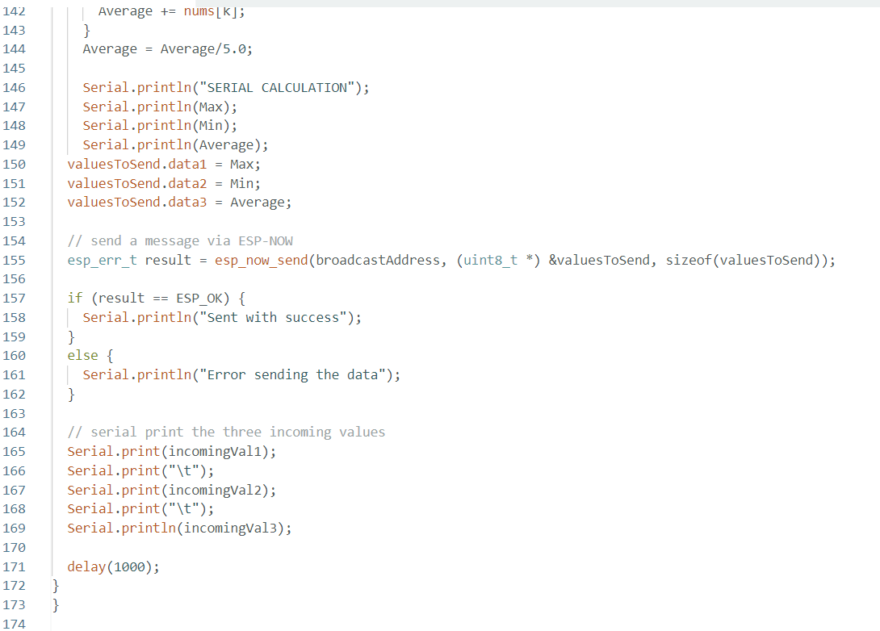
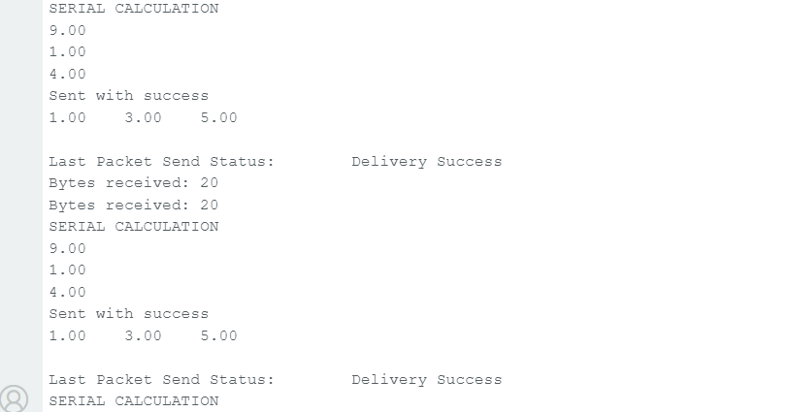

With negative numbers
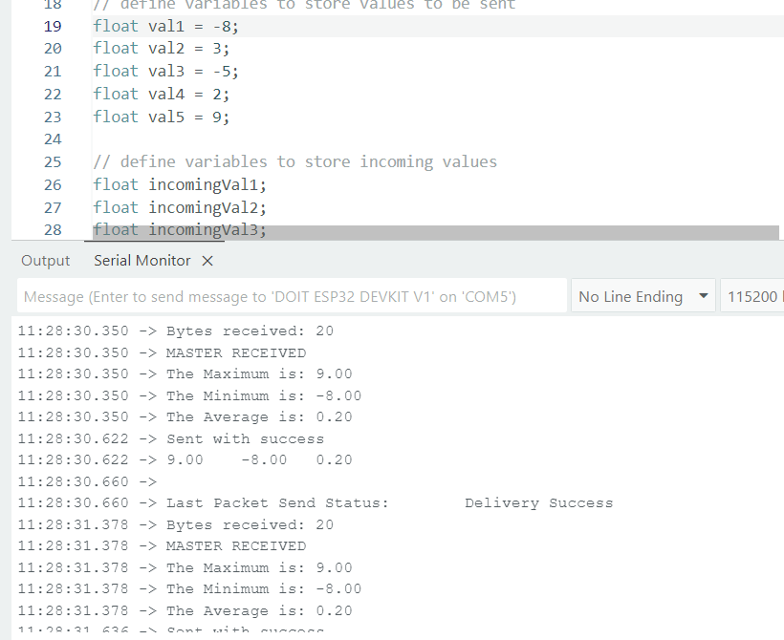

Keypad PINOUT
ESP32 - Keypad | ESP32 Tutorial
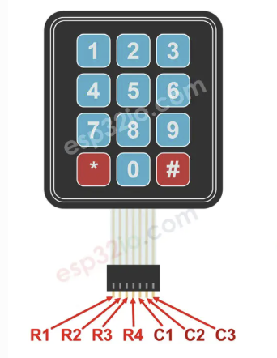R1-4 row pins
C1-3 collum pins

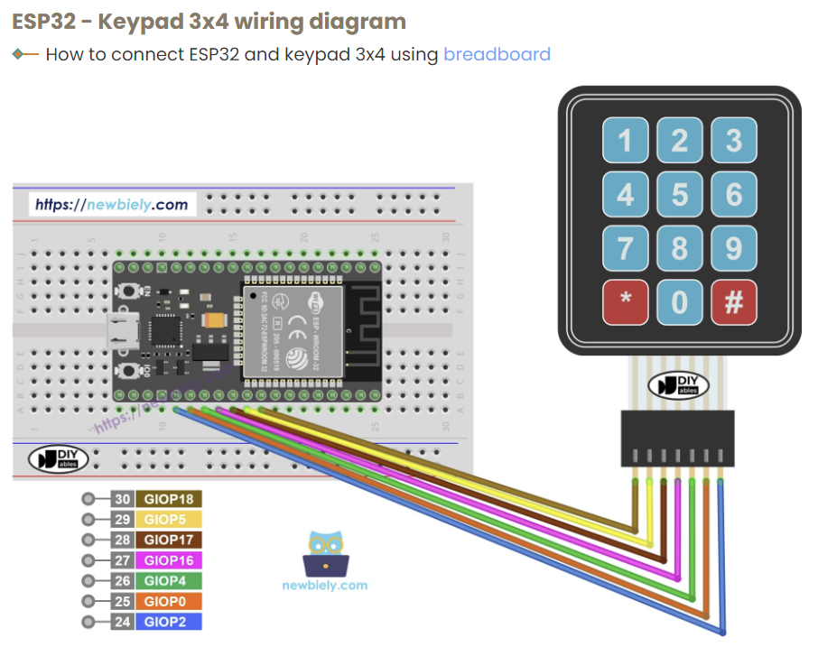

Used this code inconsistent tho some numbers didn’t appear could be bcs of header used

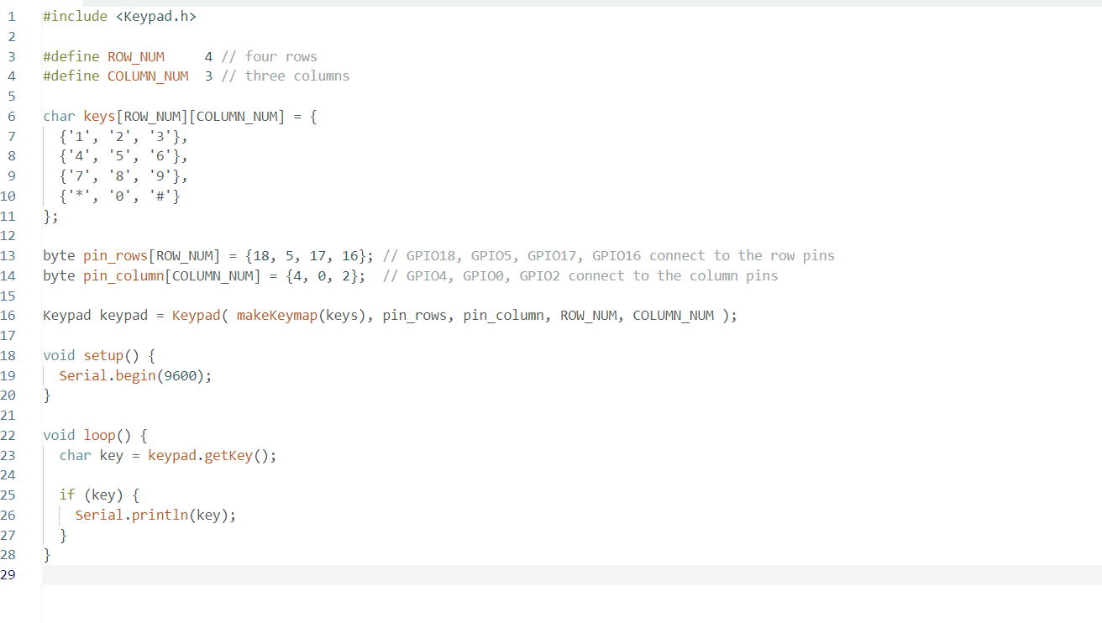

ESP32 connecting to crystal display
ESP32 - LCD 20x4 | ESP32 Tutorial
Mastering 16x2 LCD Displays: A Comprehensive ESP32 Tutorial - FritzenLab electronics
Interfacing ESP32 And 16x2 LCD Parallel Data - Makerguides.com
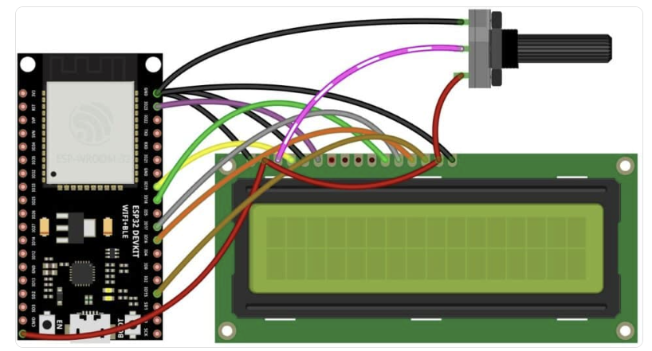
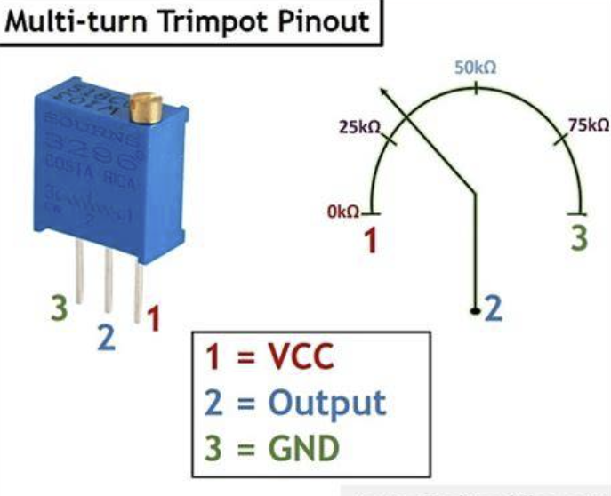
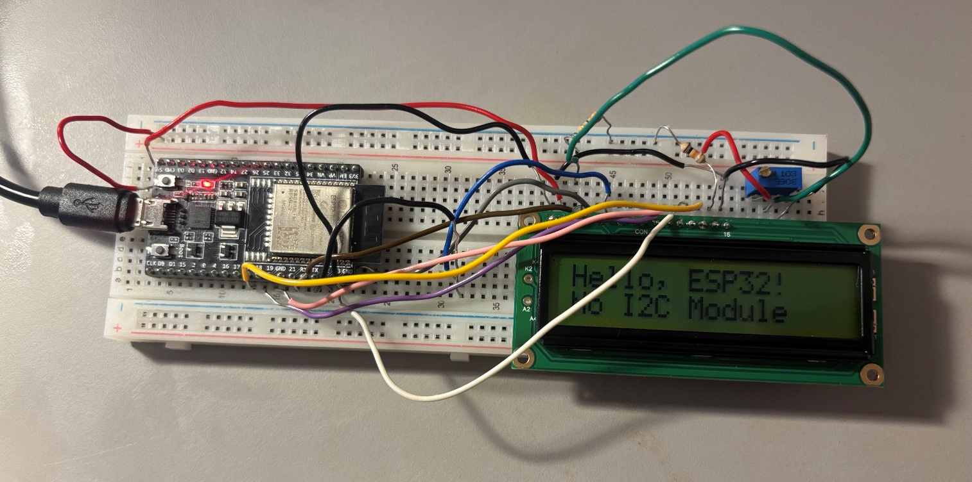
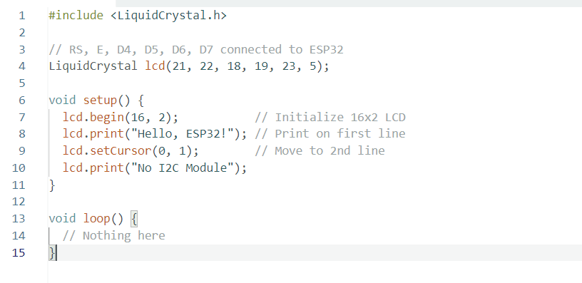

Test code to use Keypad and LCD and LED at the same time
I had to change the keypad pins as they were also needed by the gpio pins

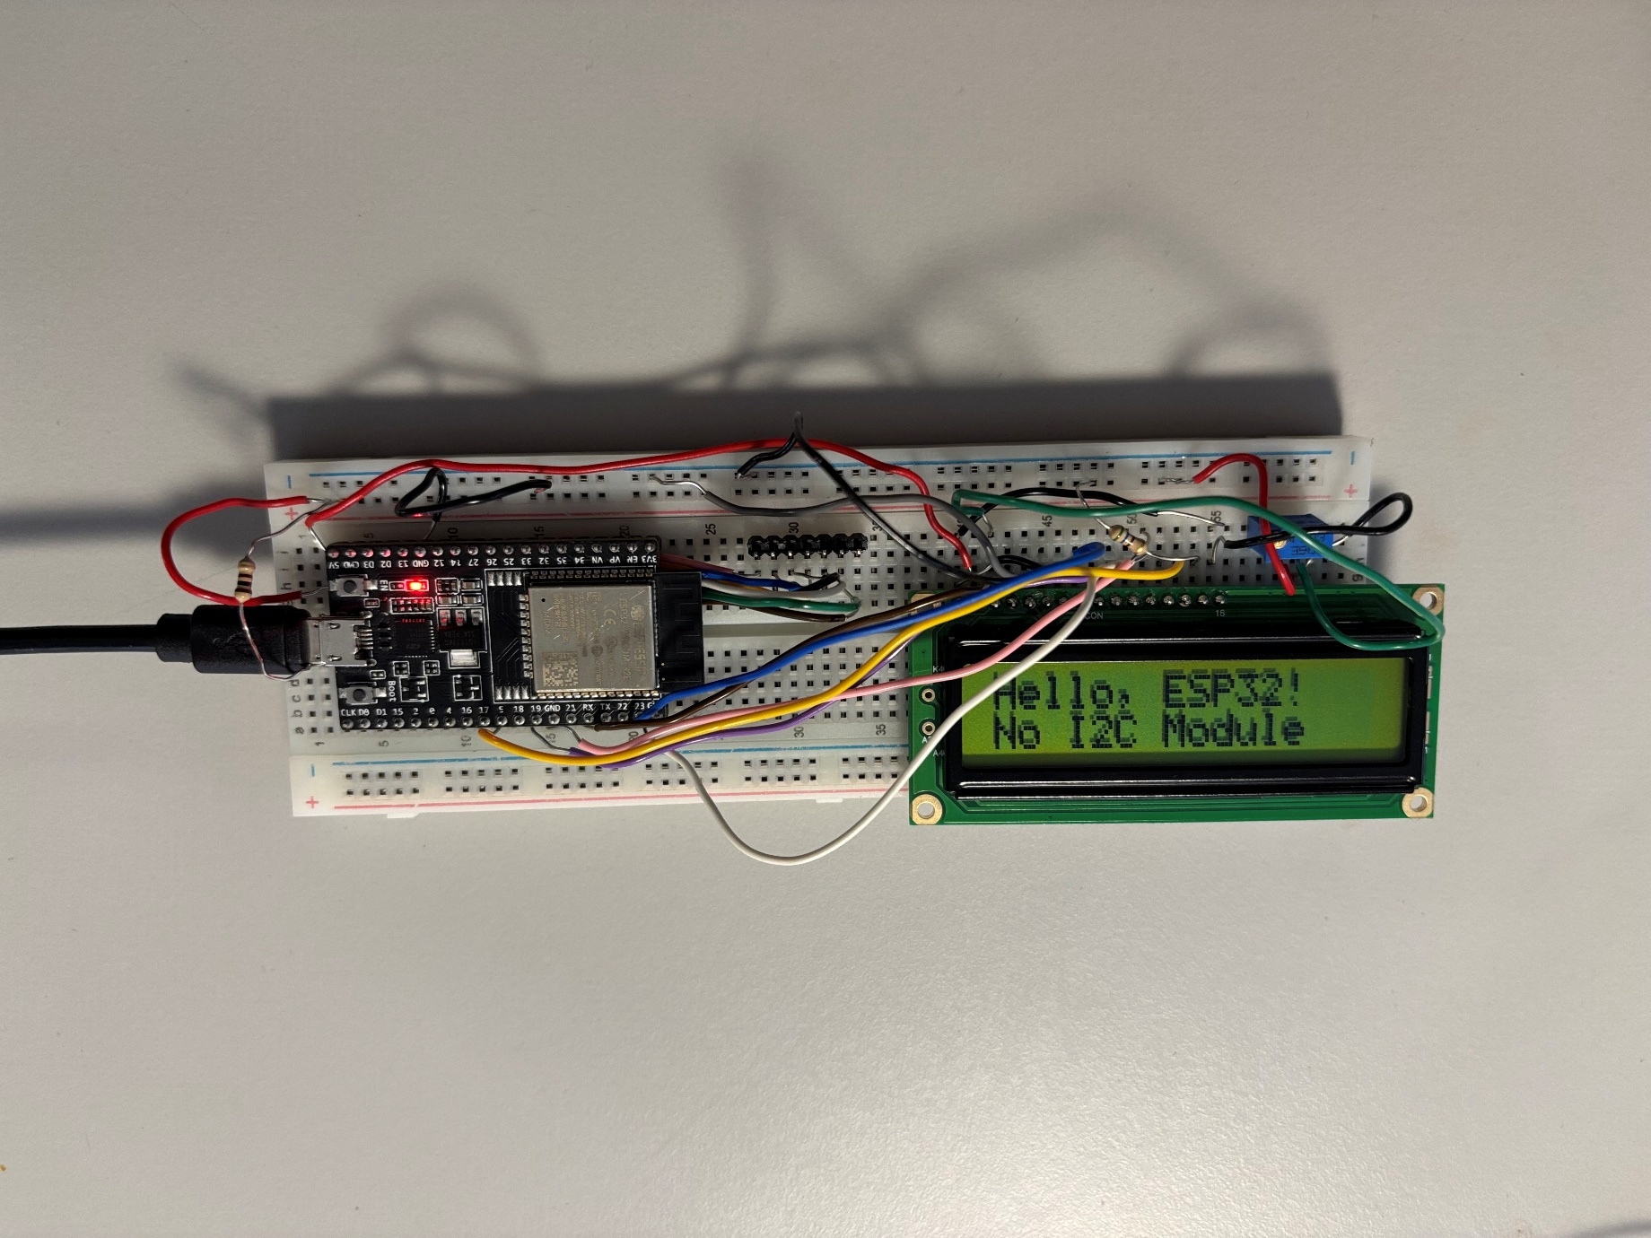
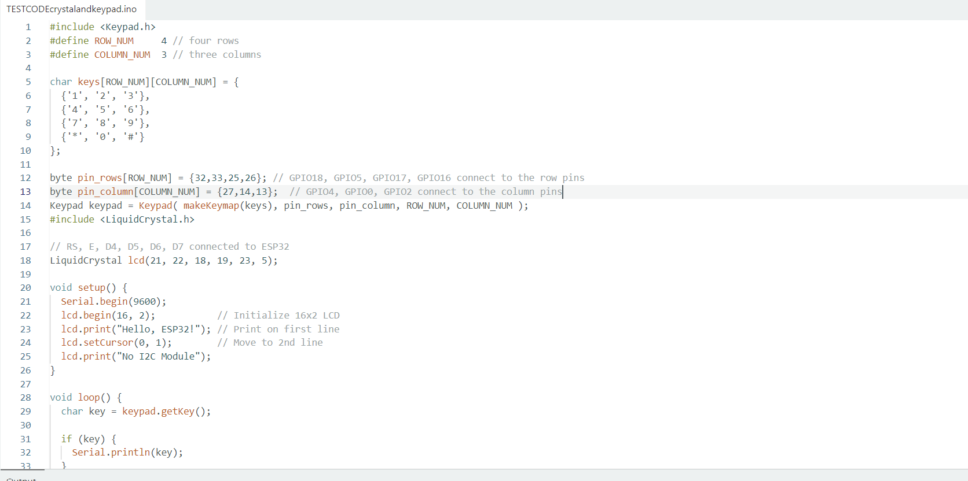
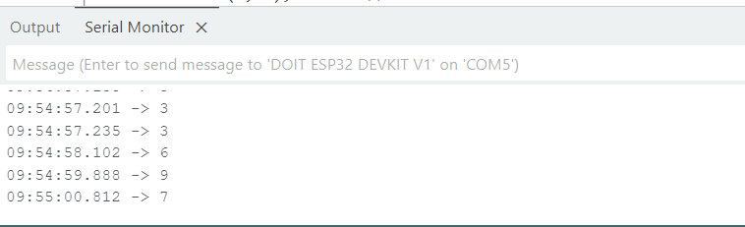

I will now make the stripboard layout
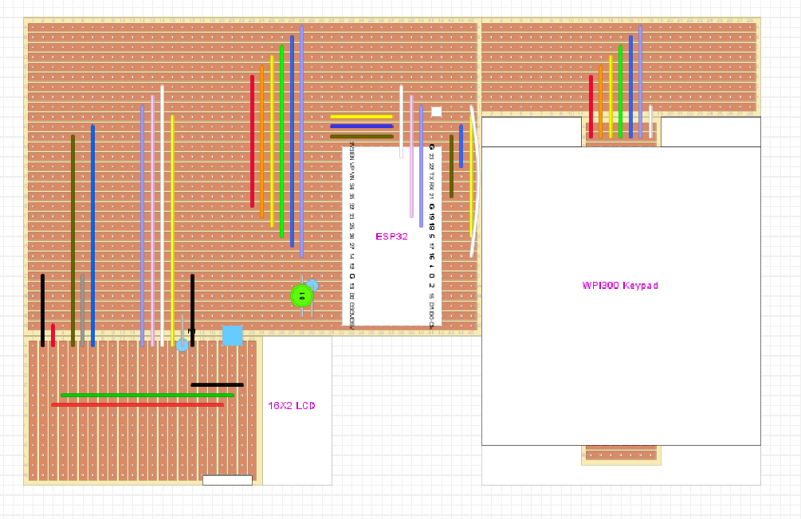
Testing strip board layout
My LCD circuit was fine I just had to turn the potentiometer. My keypad was not working correctly though the second column was behaving like the first column which implied a short circuit between them. After a continuity test this was confirmed once I desoldered this short circuit the keypad worked properly.
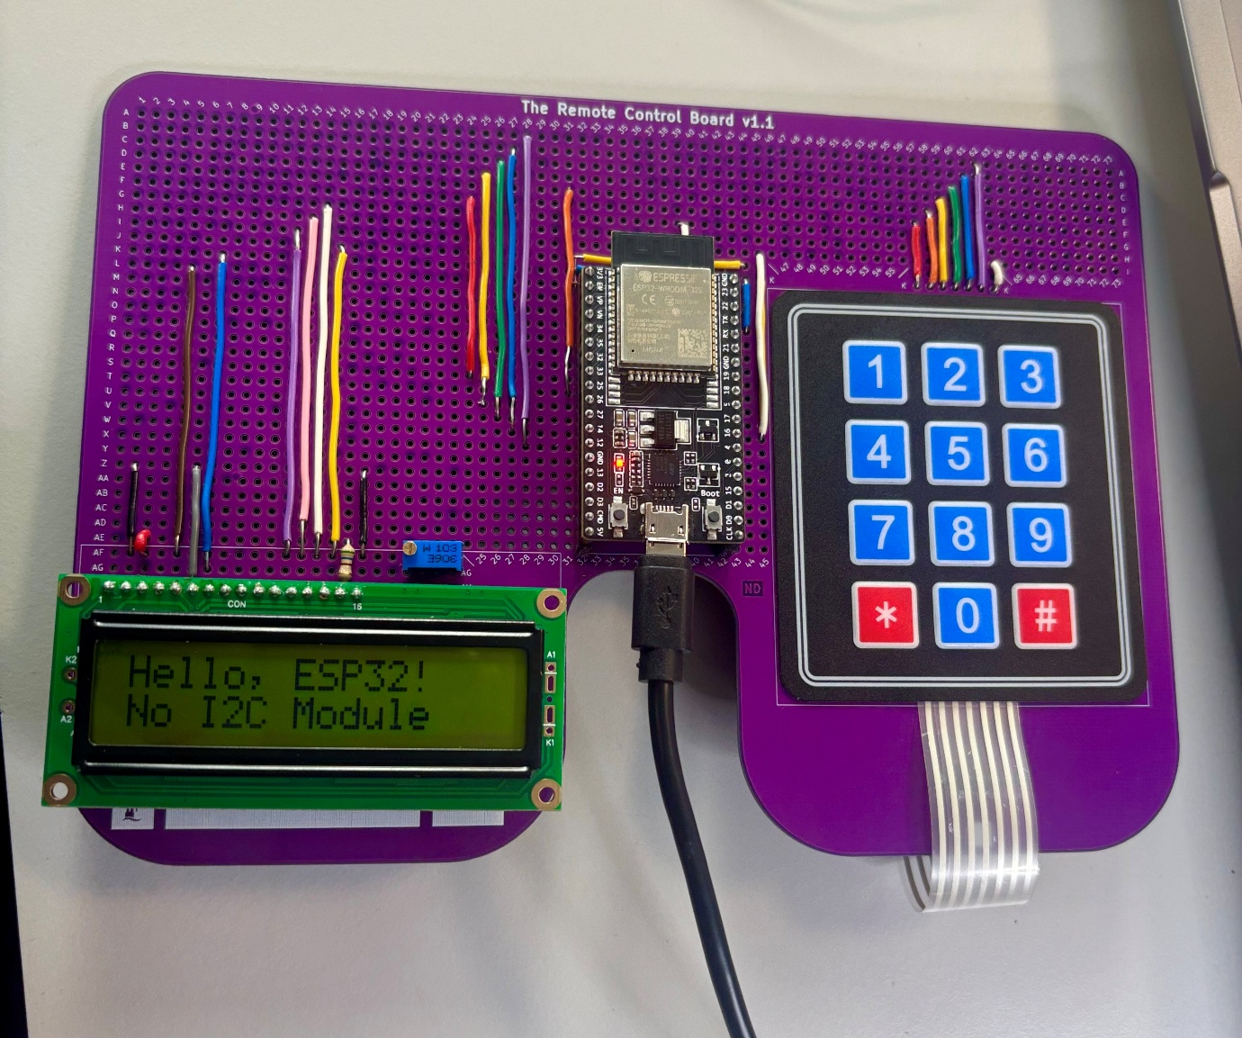
Keypad test output
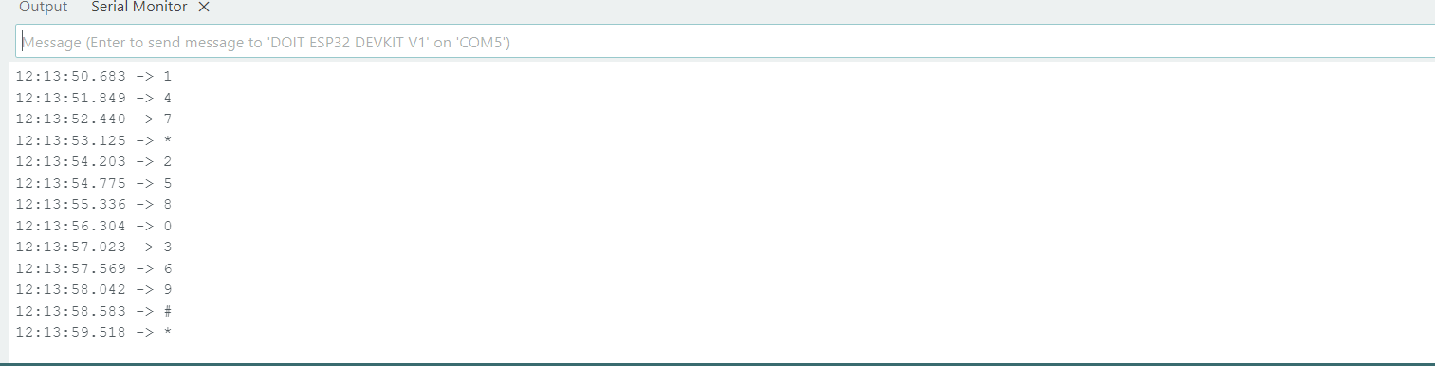

Testing espnow on remote
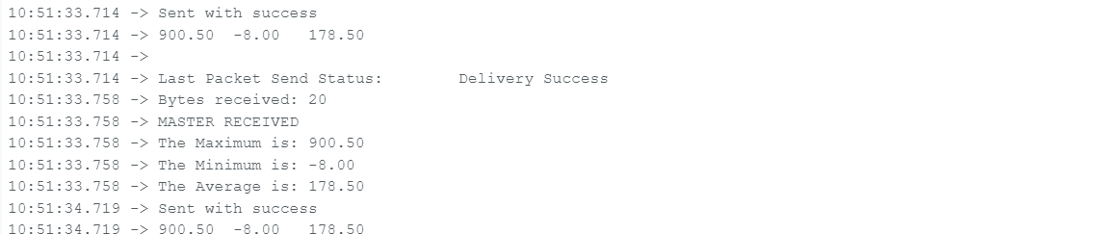

Flowchart and Keypad Diagram for maze
Left Turn
Forward
Right Turn
Backward

Remote flow chart
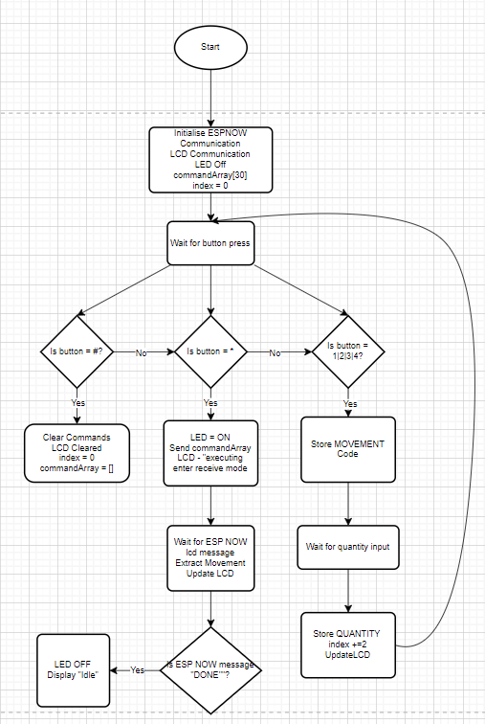

Car Flowchart
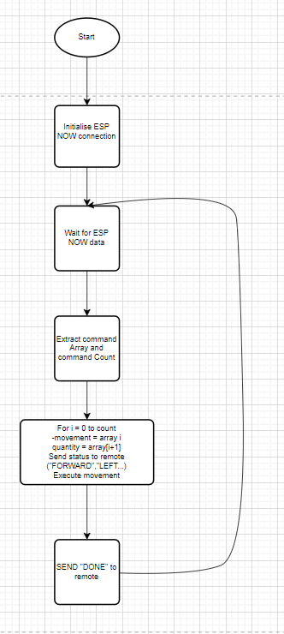
My final code has been uploaded separately
My remote successfully controls my robot. I can enter a movement command and then the distance I want it to move in that direction. My code uses the encoder count to convert the command into an accurate distance measurement so if the user enters 1 then 5 the robot will move forwards 50 cm.

